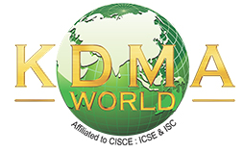

Karam Devi Memorial Academy, World
Cluster - I Examination 2024-25
Date | Day | IX | X | XII
11/05/24 | Saturday | MATHS / EVS | BIOLOGY | CHEM / ECO
12/05/24 | Sunday
13/05/24 | Monday | ----- | ----- | -----
14/05/24 | Tuesday | PHY / COMM. ST. | HCG – II | ENGLISH – I
15/05/24 | Wednesday | ----- | ----- | -----
16/05/24 | Thursday | HCG – I | ENGLISH – II | -----
17/05/24 | Friday |  | ----- | -----
18/05/24 | Saturday | BIOLOGY | MATHS / EVS | MATHS / BIO./HISTORY
19/05/24 | Sunday
20/05/24 | Monday | HCG – II | HCG – I | ENGLISH – II
21/05/24 | Tuesday | HINDI | ENGLISH – I | -----
22/05/24 | Wednesday | ENGLISH – I | COMP. / P.ED. | COMMERCE
23/05/24 | Thursday | COMP. / P.ED. | HINDI | COMP./HINDI
24/05/24 | Friday | ----- | ----- | -----
25/05/24 | Saturday | ENGLISH – II | CHEMISTRY | PHY / ACC
26/05/24 | Sunday
27/05/24 | Monday | CHEMISTRY | PHY / COMM. ST. | P.ED.

